1:stock maintenance system

Use case diagram

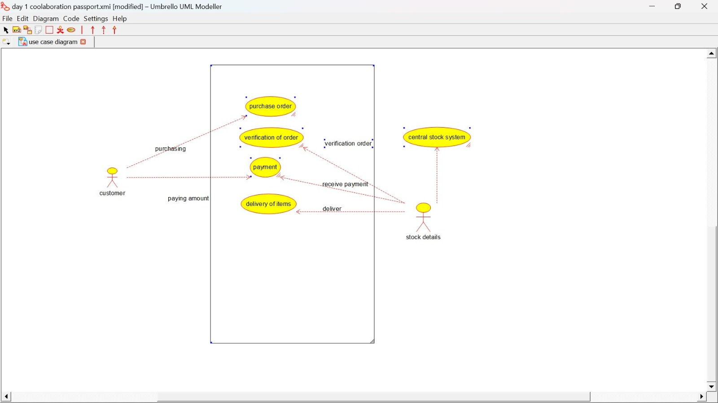

Class diagram:

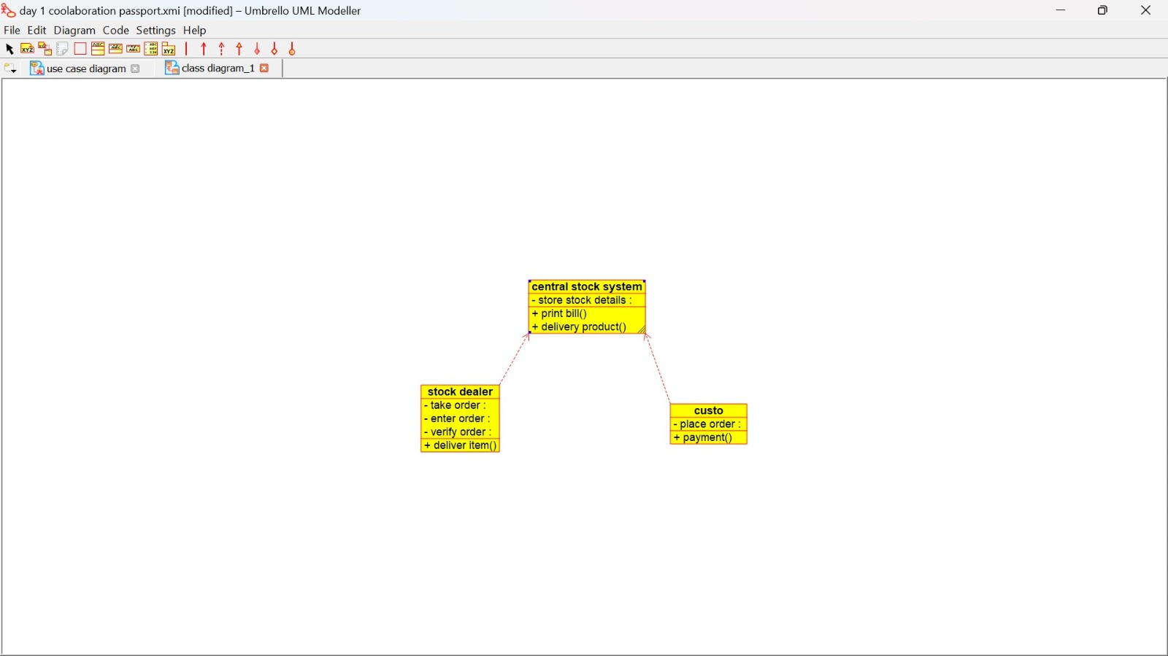

Activity diagram:

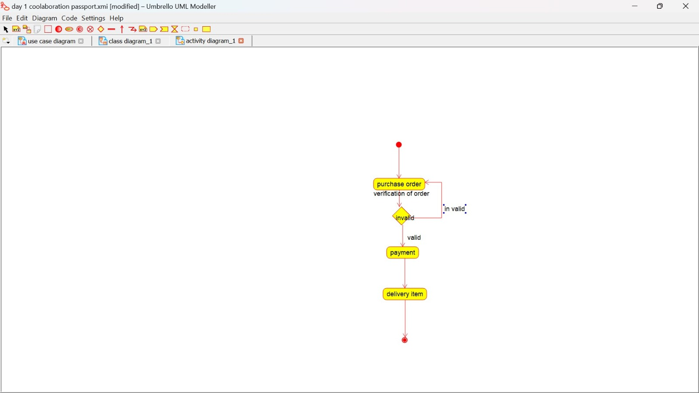

Sequence diagram:

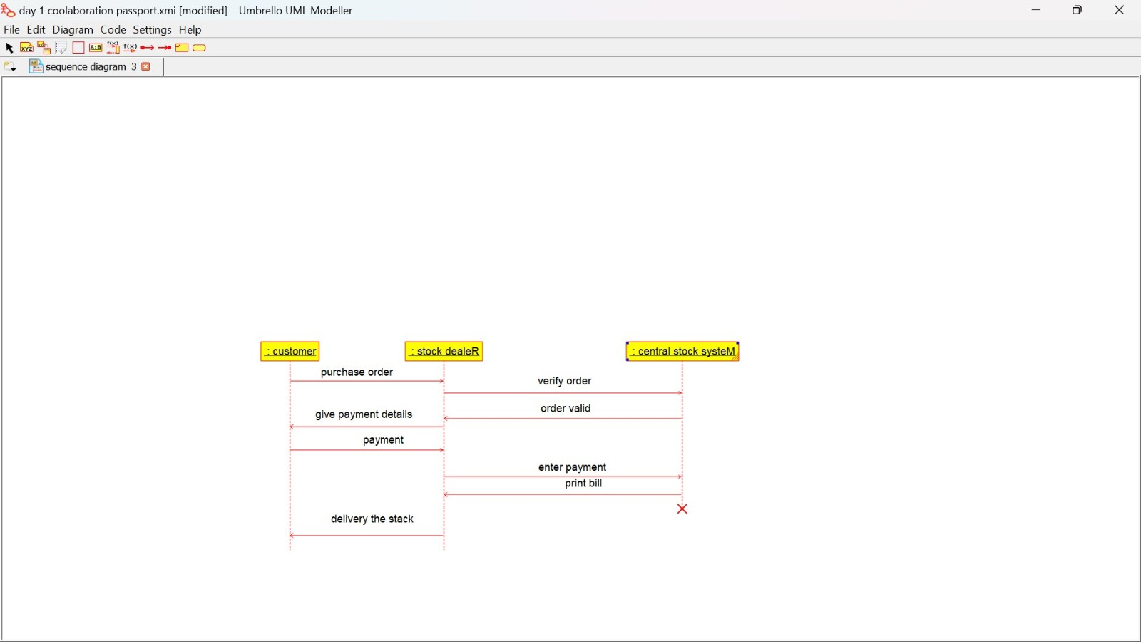

Collaboration diagram:

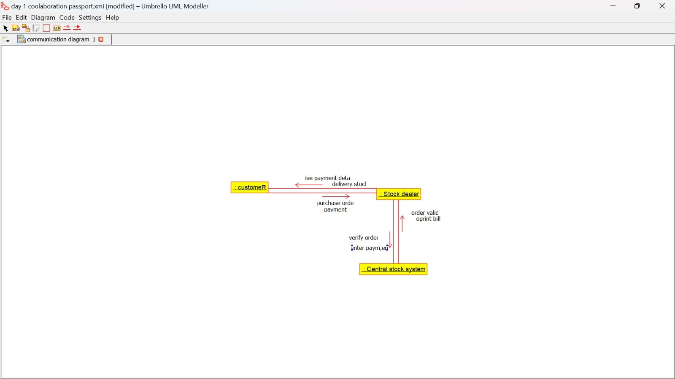

State chart diagram:

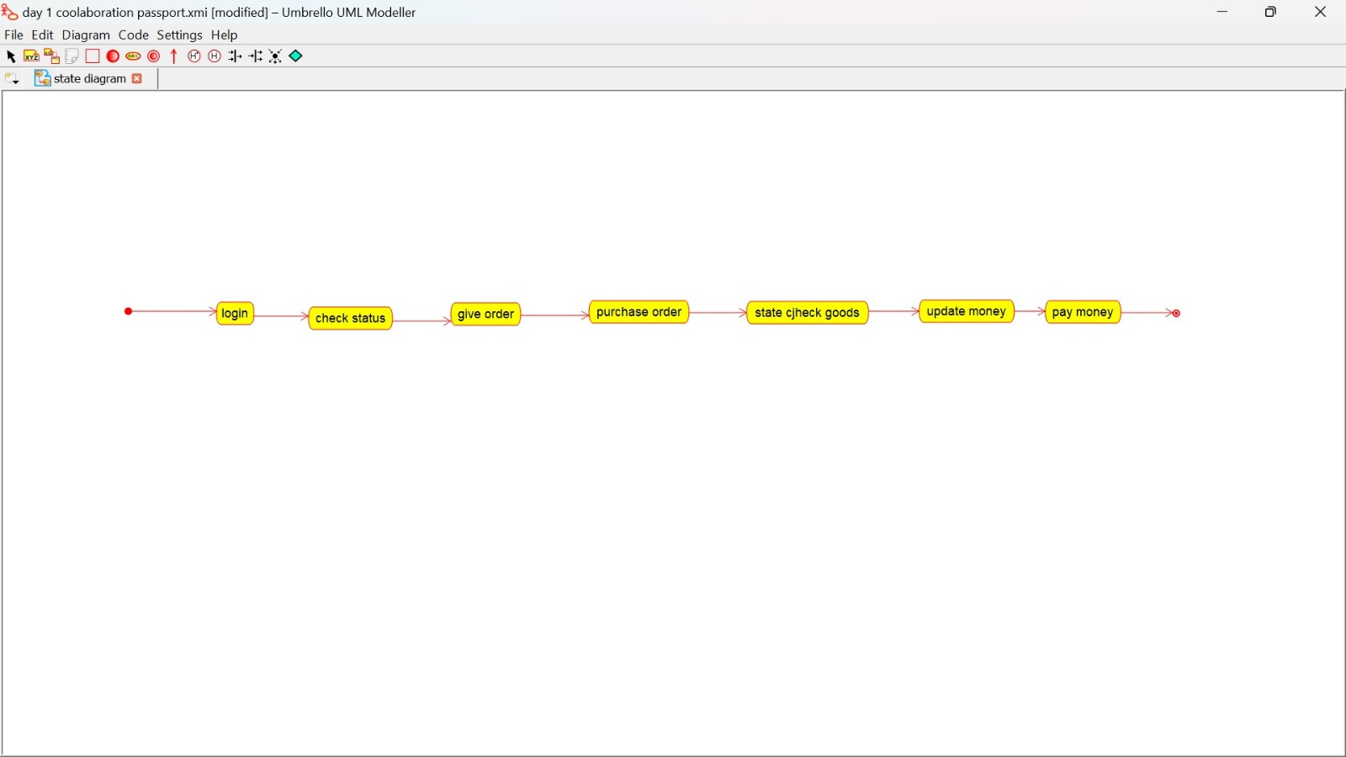

Component diagram:

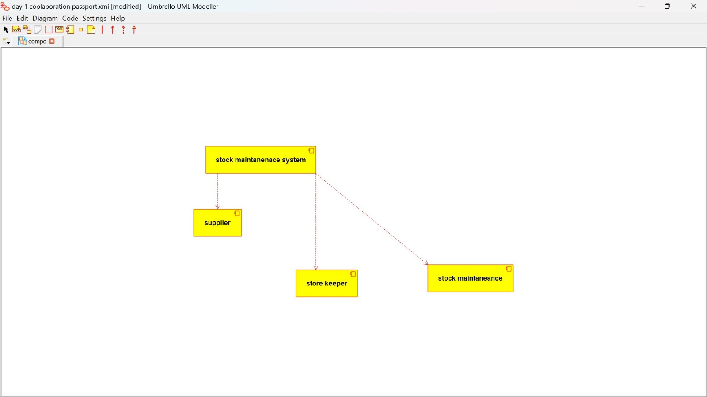

Deployment diagram:

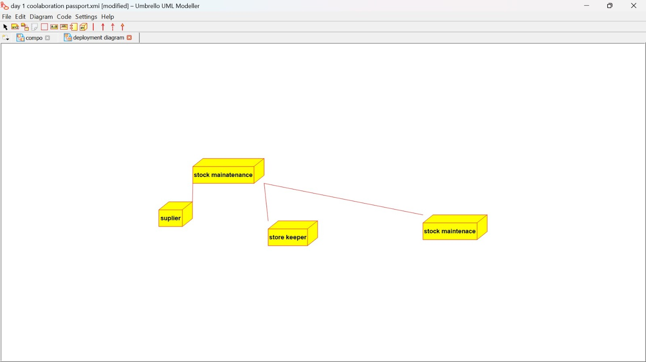

Package diagram:

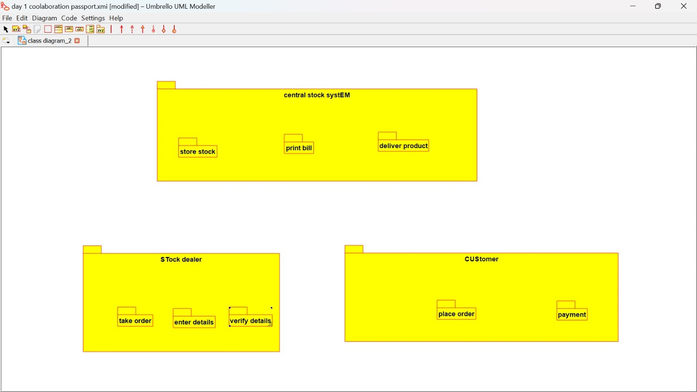

Program:

**CENTRAL STOCK SYSTEM:**

Public central stock system

{

Public integer store stock details;

Public void print bill()

{

}

Public void deliver product()

{

}

}

**CUSTOMER:**

Public class customer

{

Public integer place order;

Public void payment()

{

}

}

**STOCK DEALER:**

Public class stock dealer

{

Public integer take order;

Pubic integer enter details;

Public integer verify details;

Public void deliver item()

{

}

}

**2:EXAM REGISTRATION SYSTEM**

**use case diagram:**

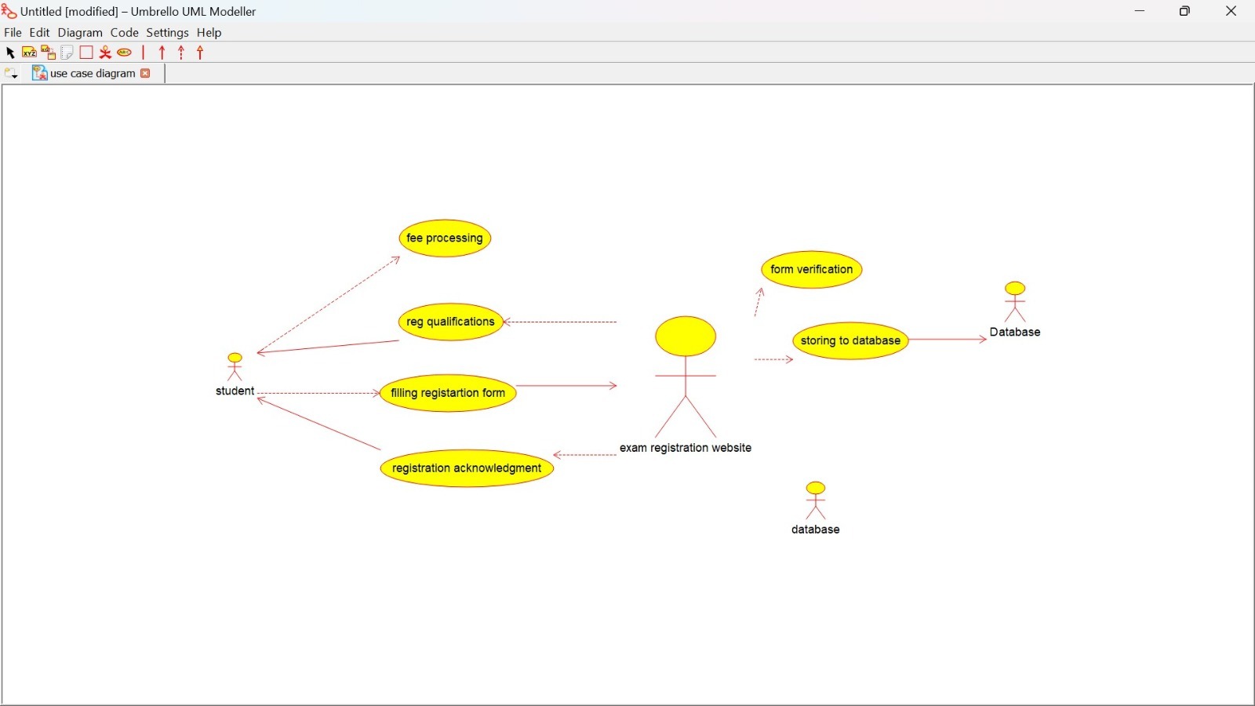

**Class diagram:**

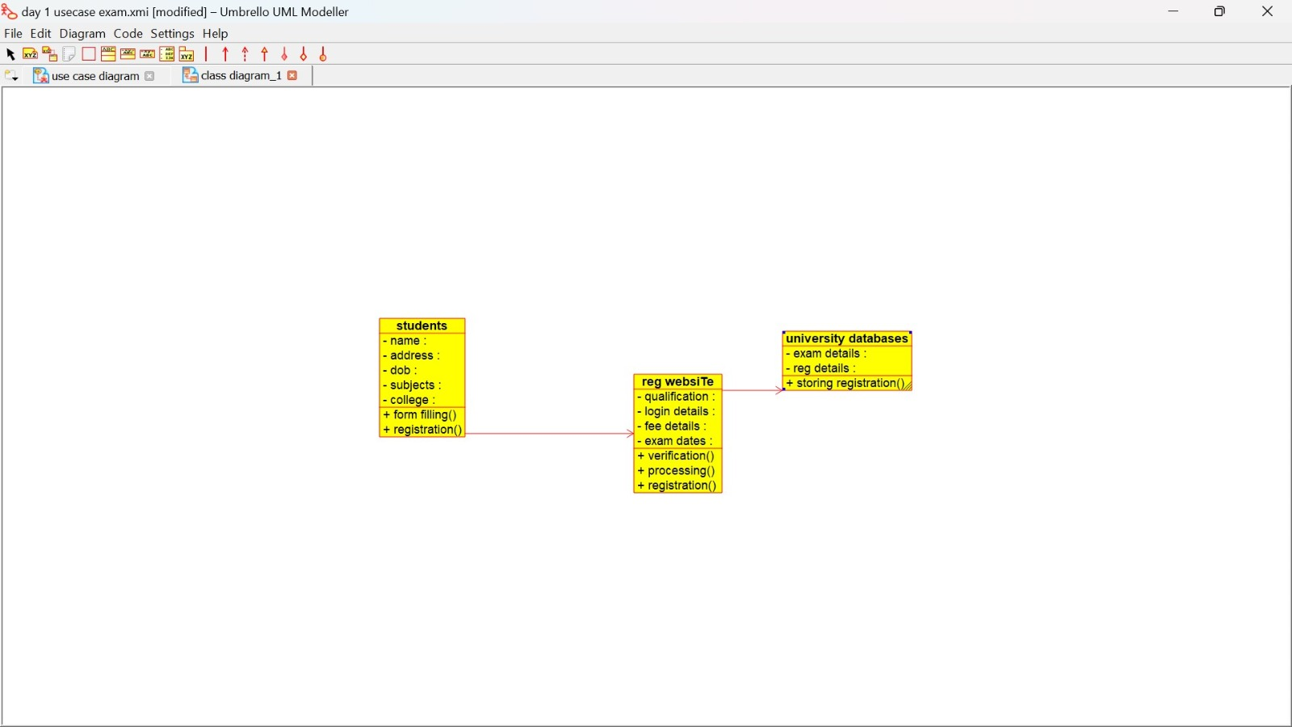

**Activity diagram:**

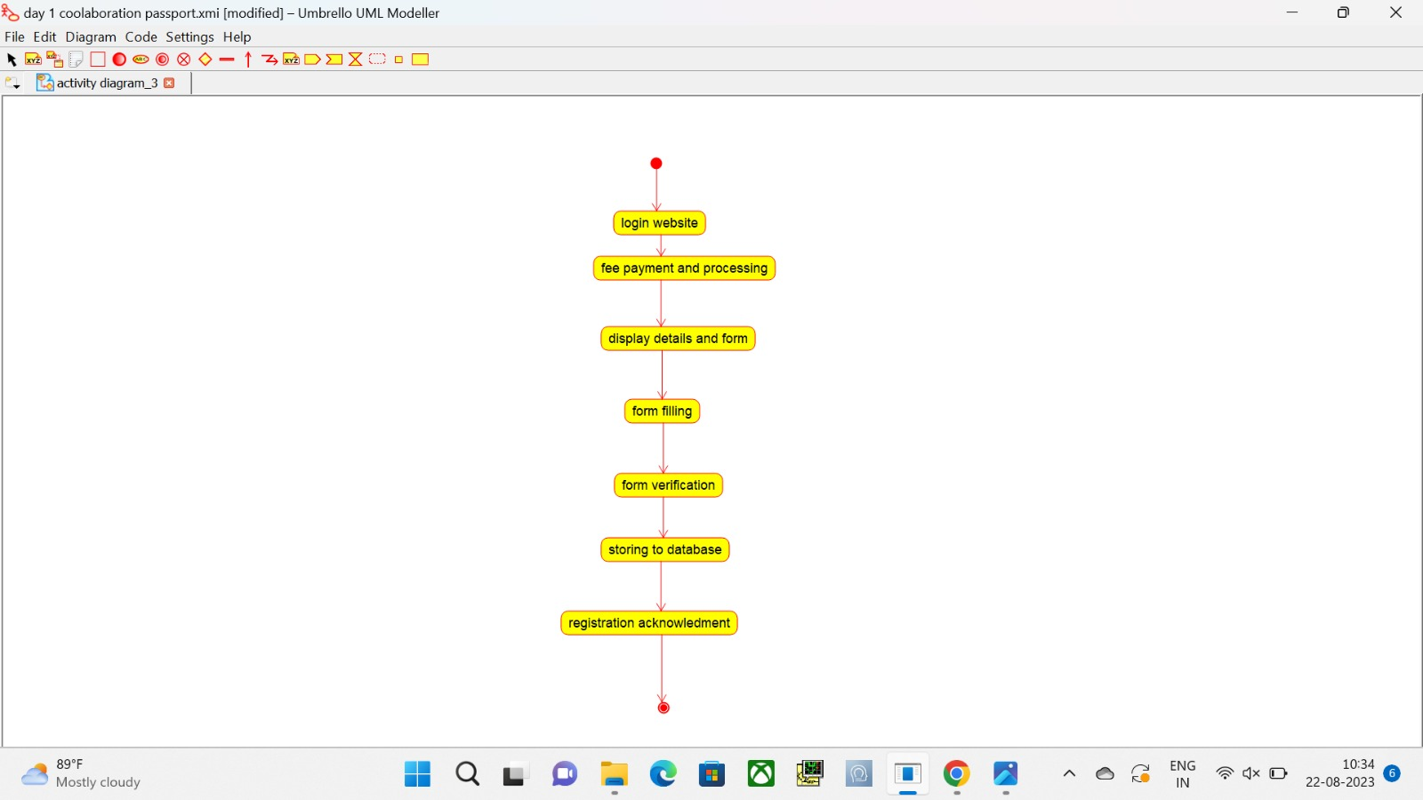

**Sequence diagram:**

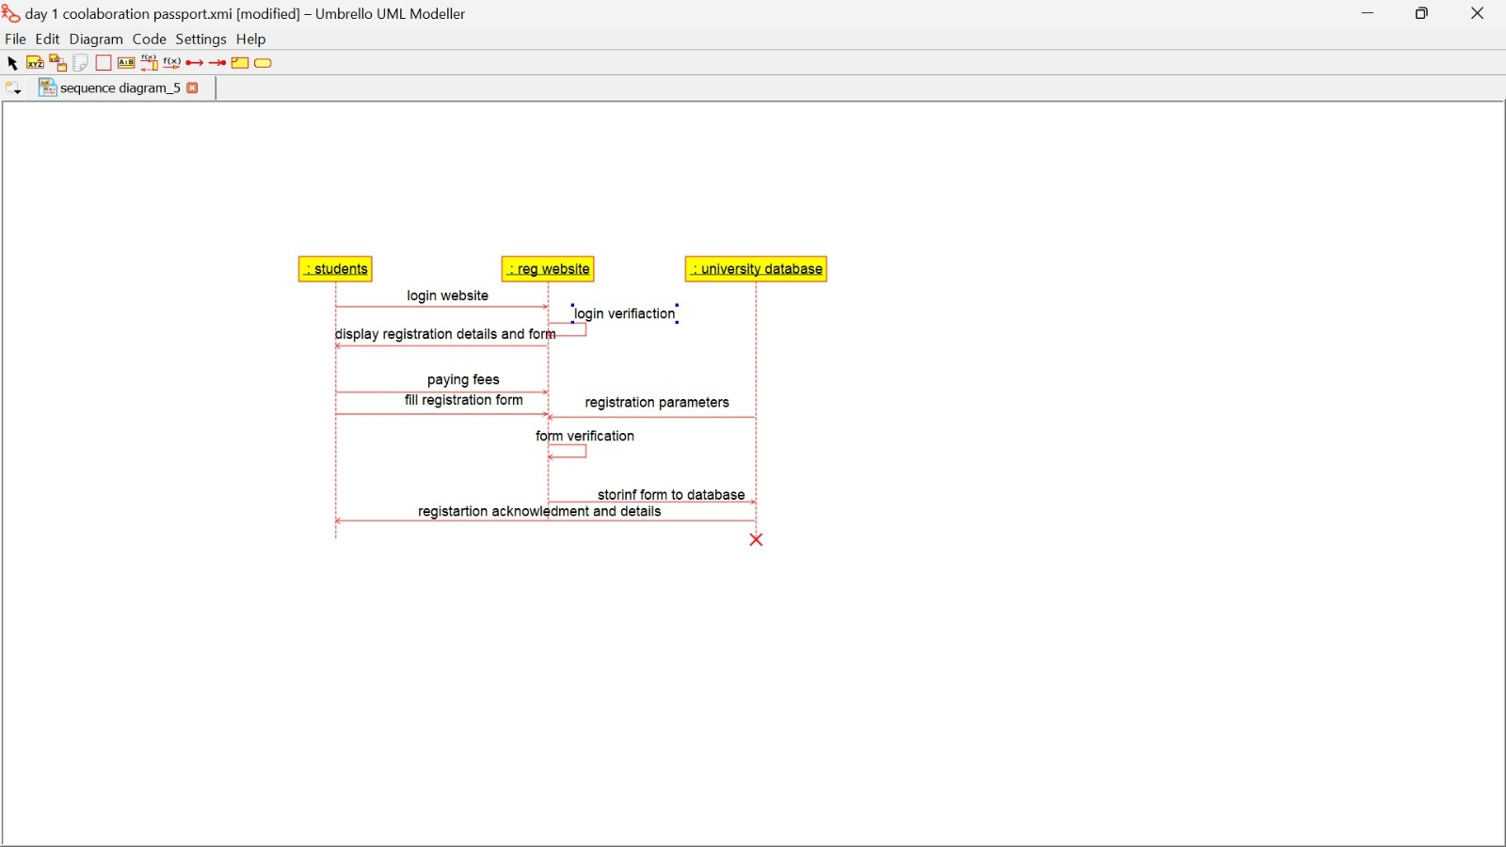

**Collaboration diagram:**

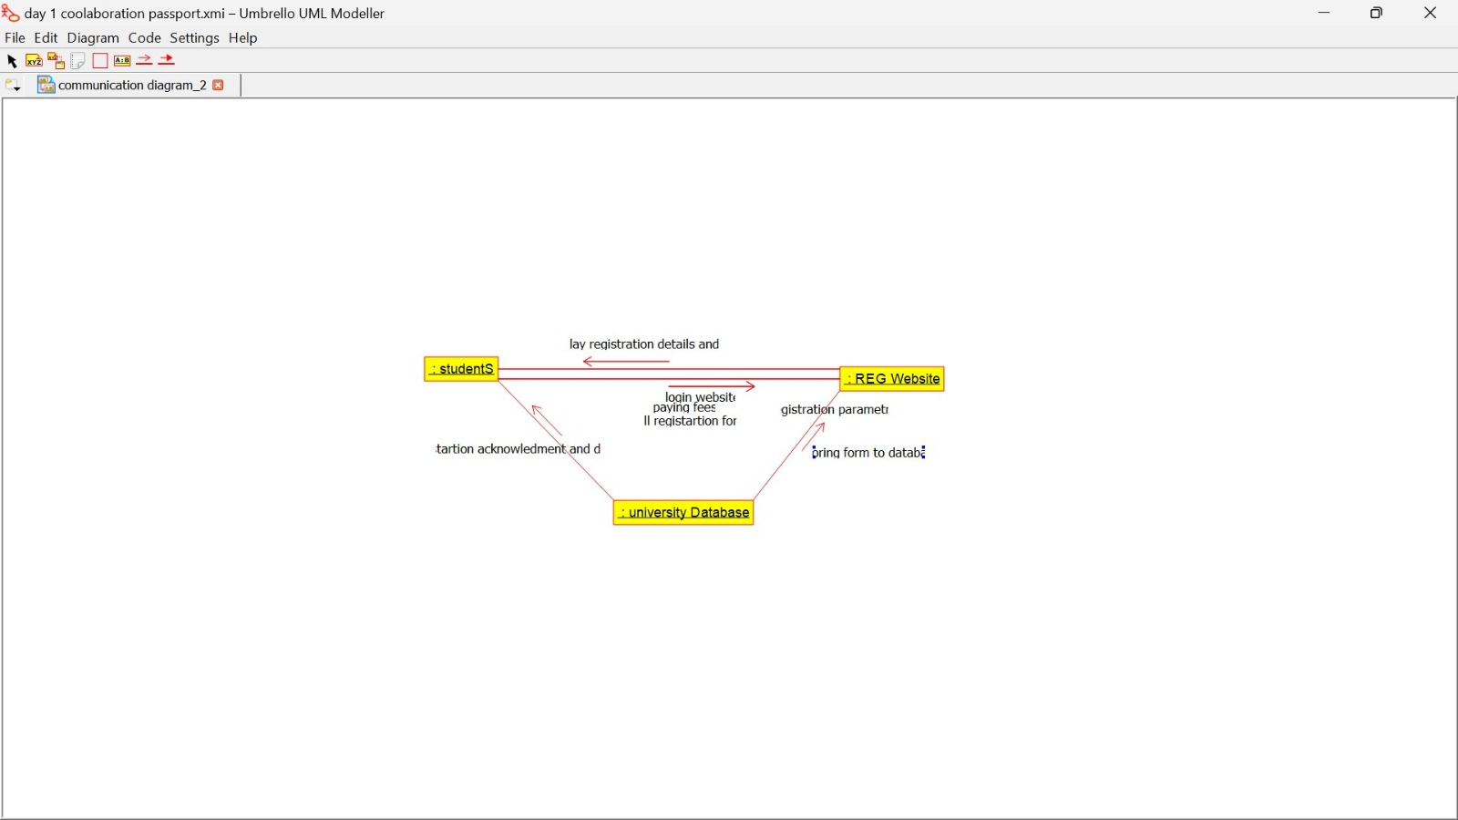

**State chart diagram:**

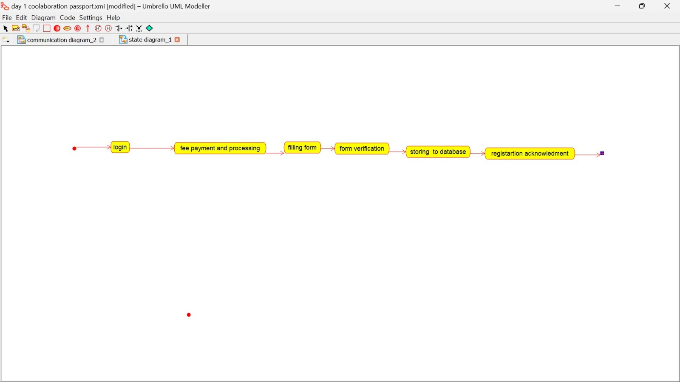

**Component diagram:**

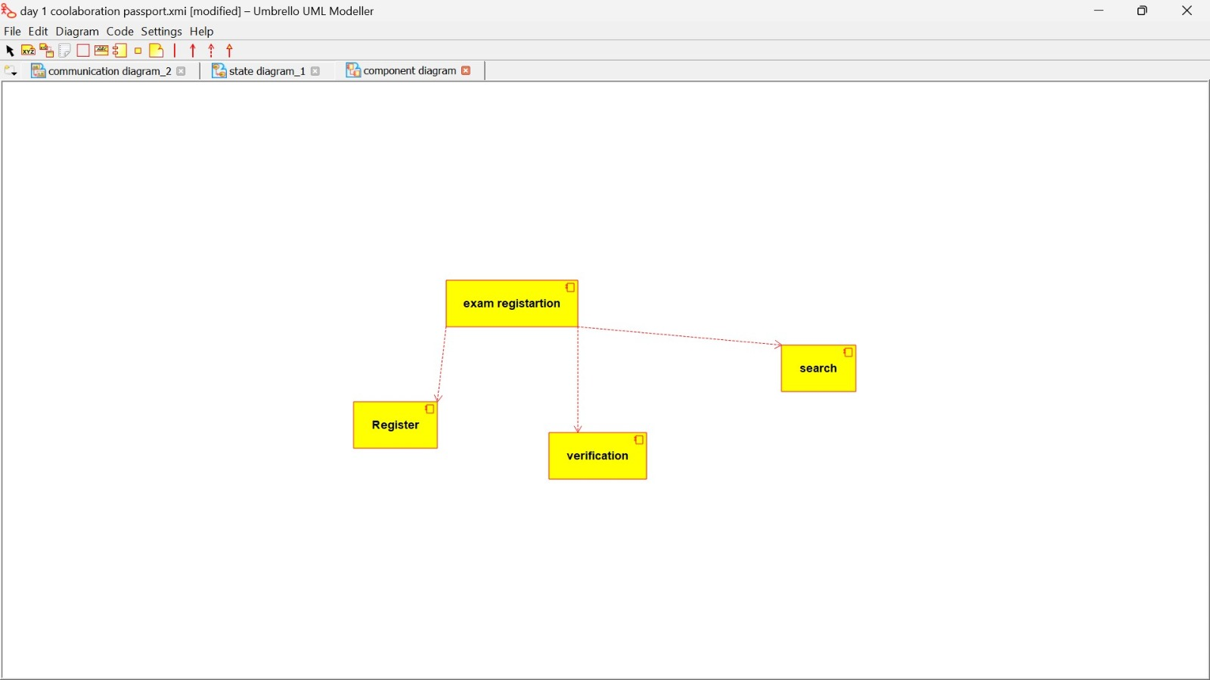

**Deployment diagram:**

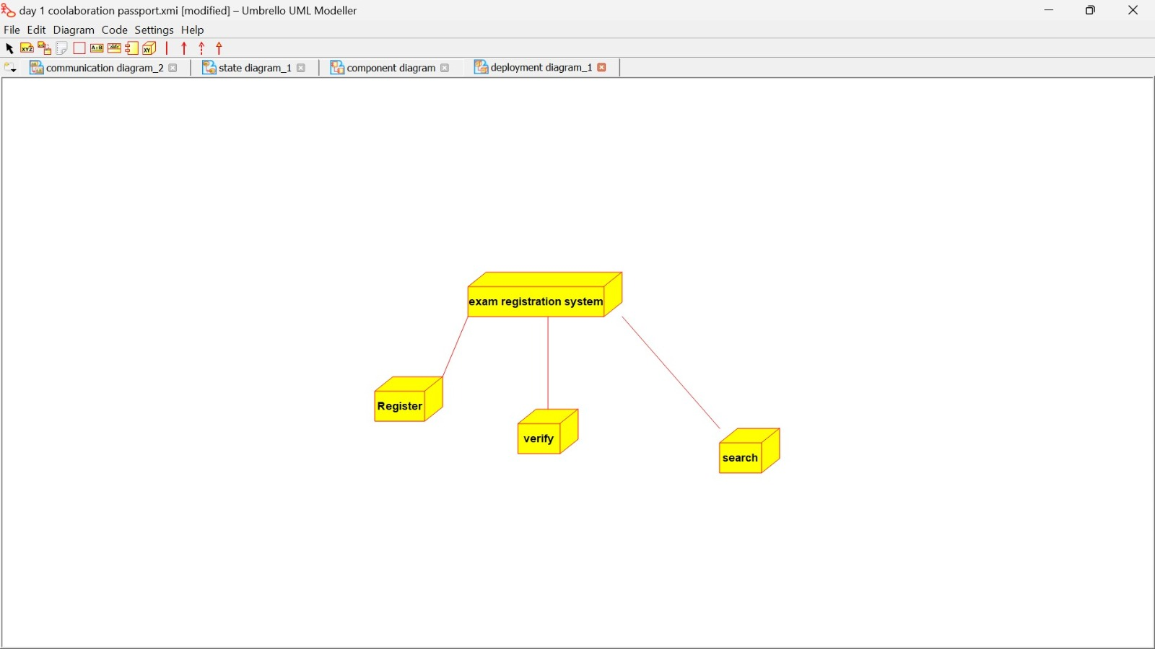

**Package diagram:**

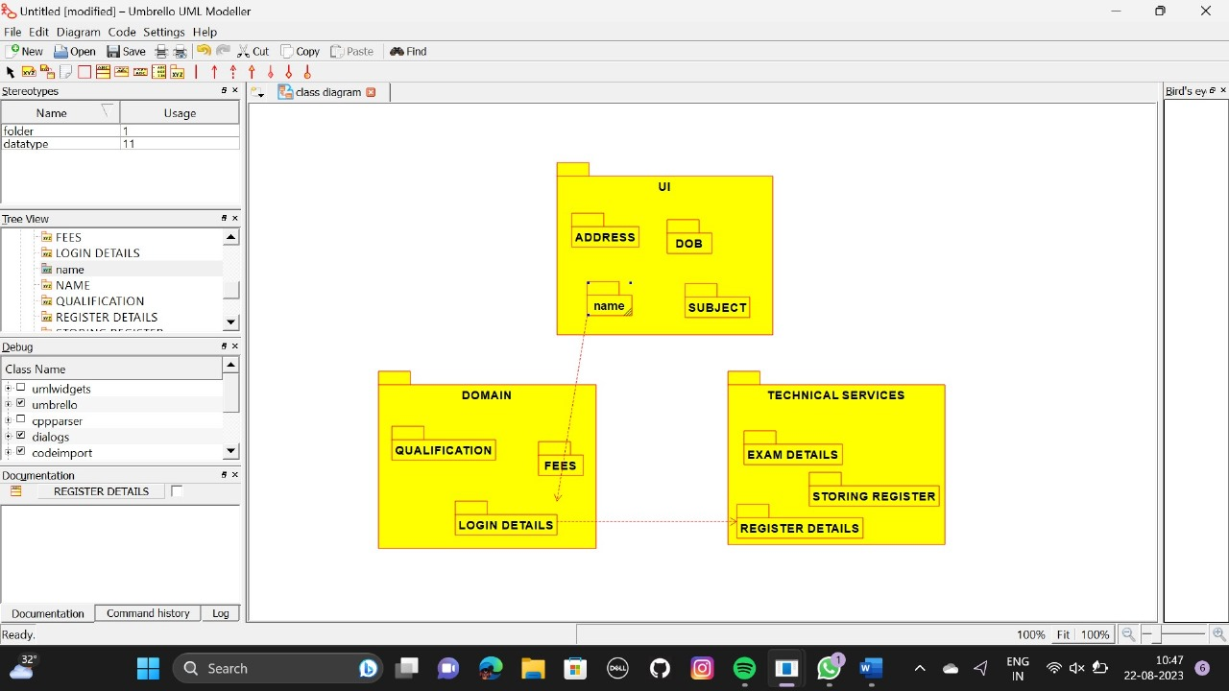

**Program:**

**CENETRAL EDUATIONAL SYSTEM:**

Public class central educational system

{

Public integer student details;

Public void valid proof()

{

}

}

**EDUCATIONAL OFFICER:**

Public class educational officer

{

Public integer id no;

Public string name;

Public void verification of proof()

{

}

Public void issue hall ticket()

{

}

}

**STUDENT:**

Public class student

{

Public integer student details;

Public void payment of fees()

{

}

Public void receive hall ticket()

{

}

}

**3:online course reservation system**

**Use case diagram:**

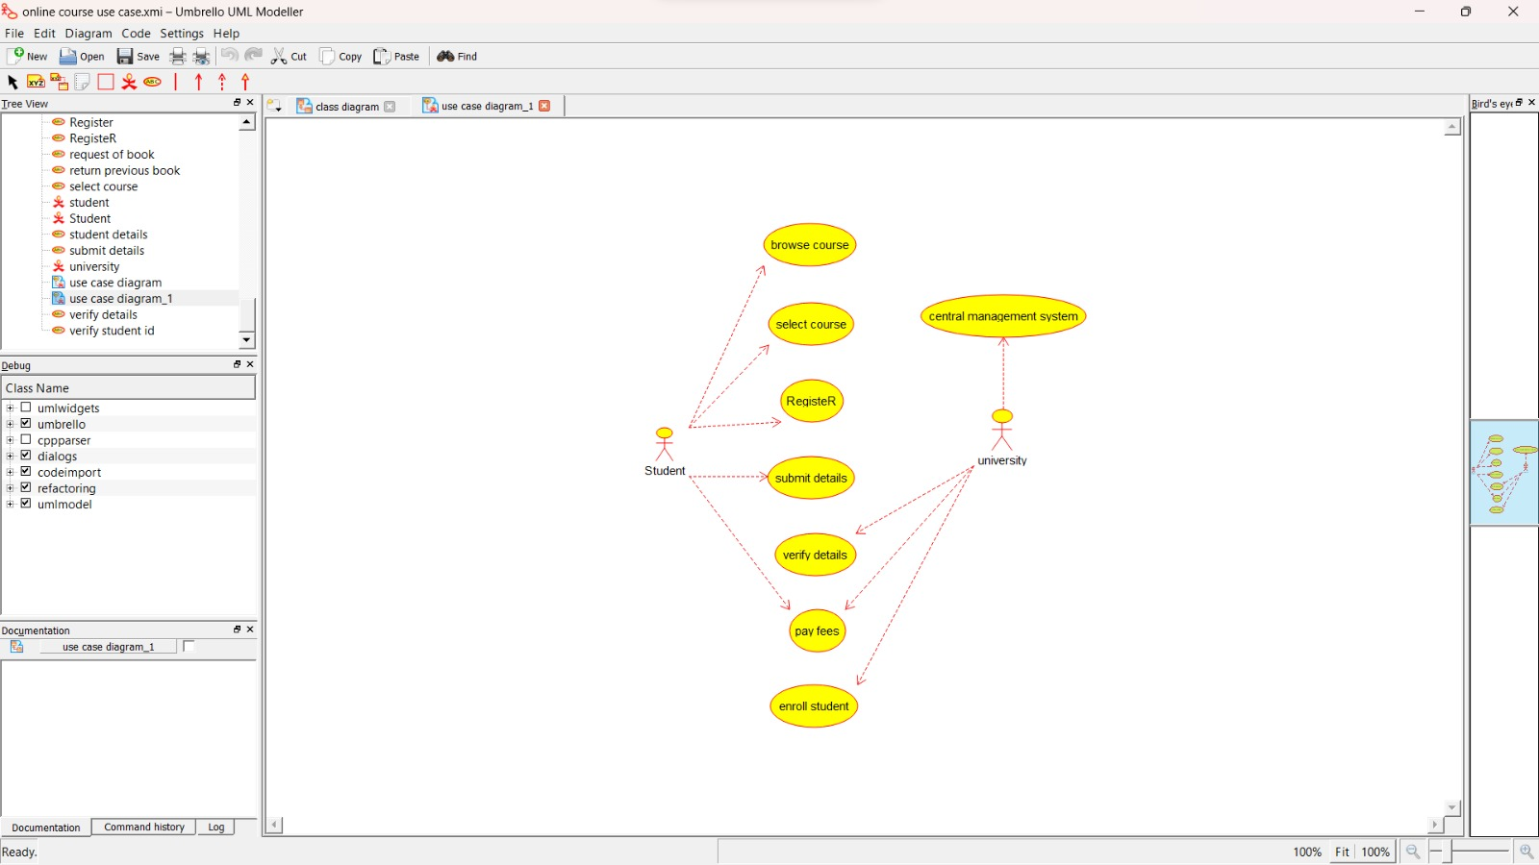

**Class diagram:**

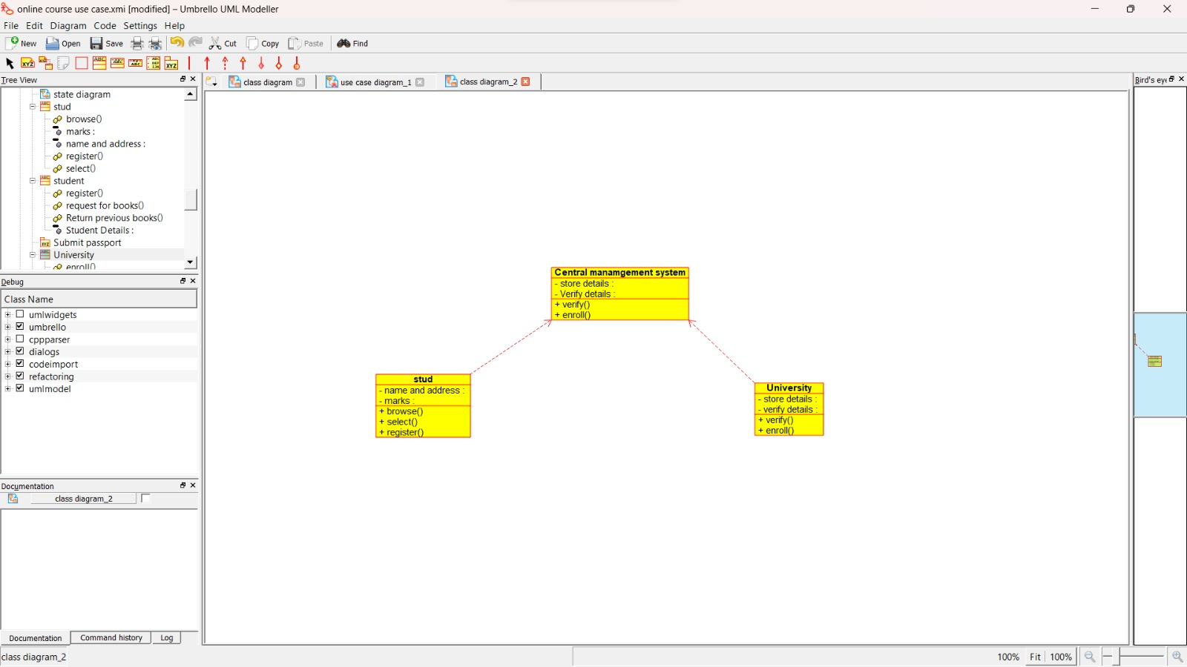

**Activity diagram:**

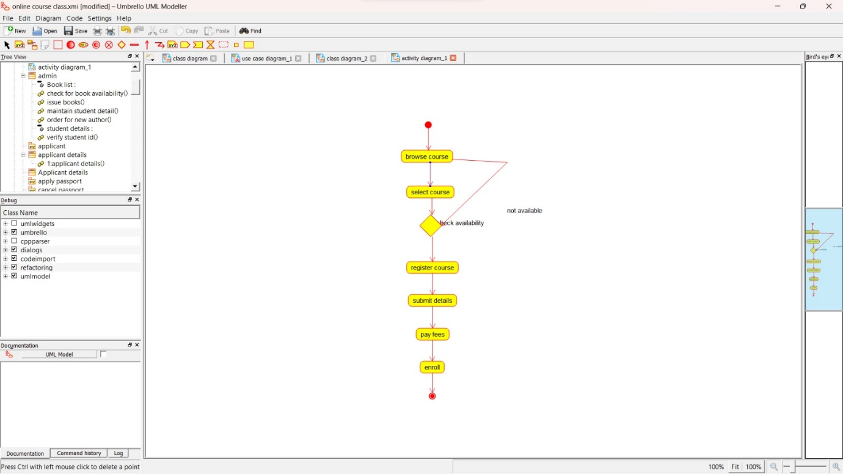

**Sequence diagram:**

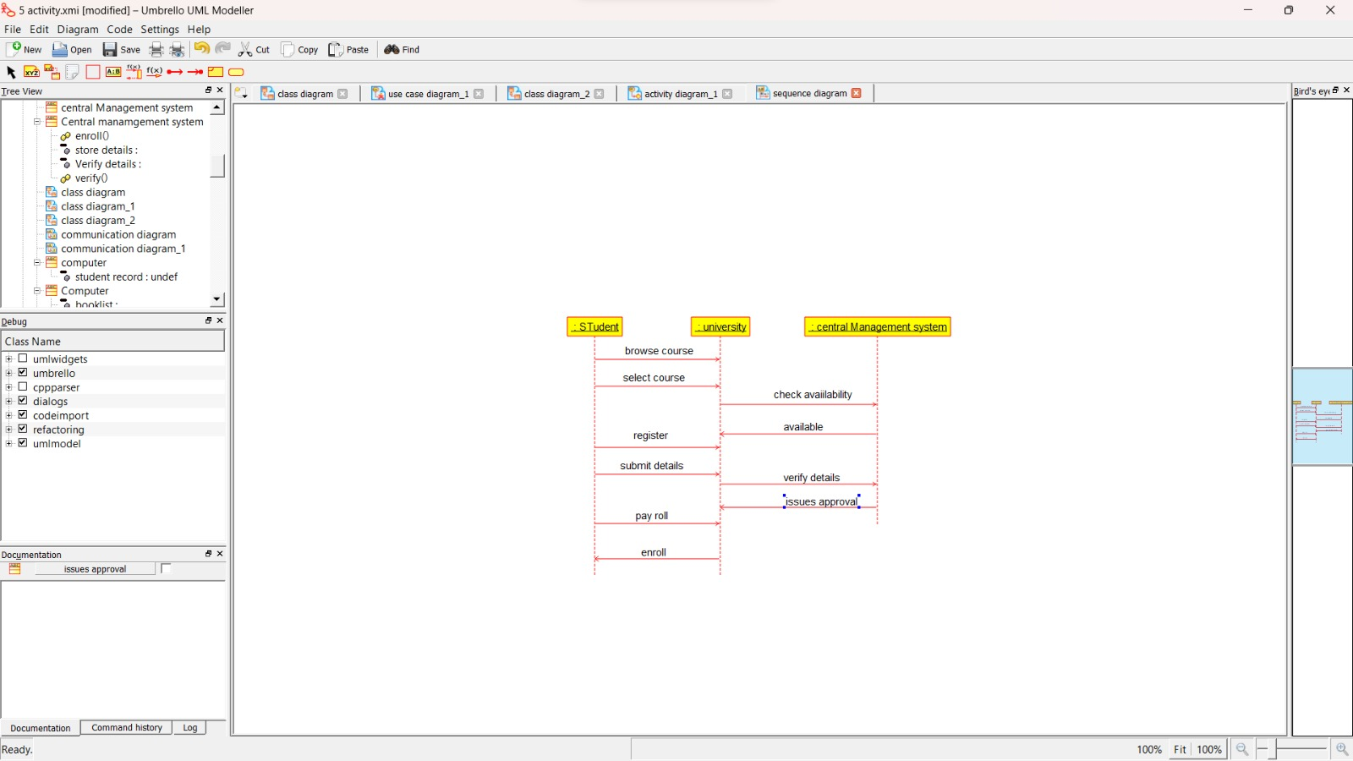

**Collaboration diagram:**

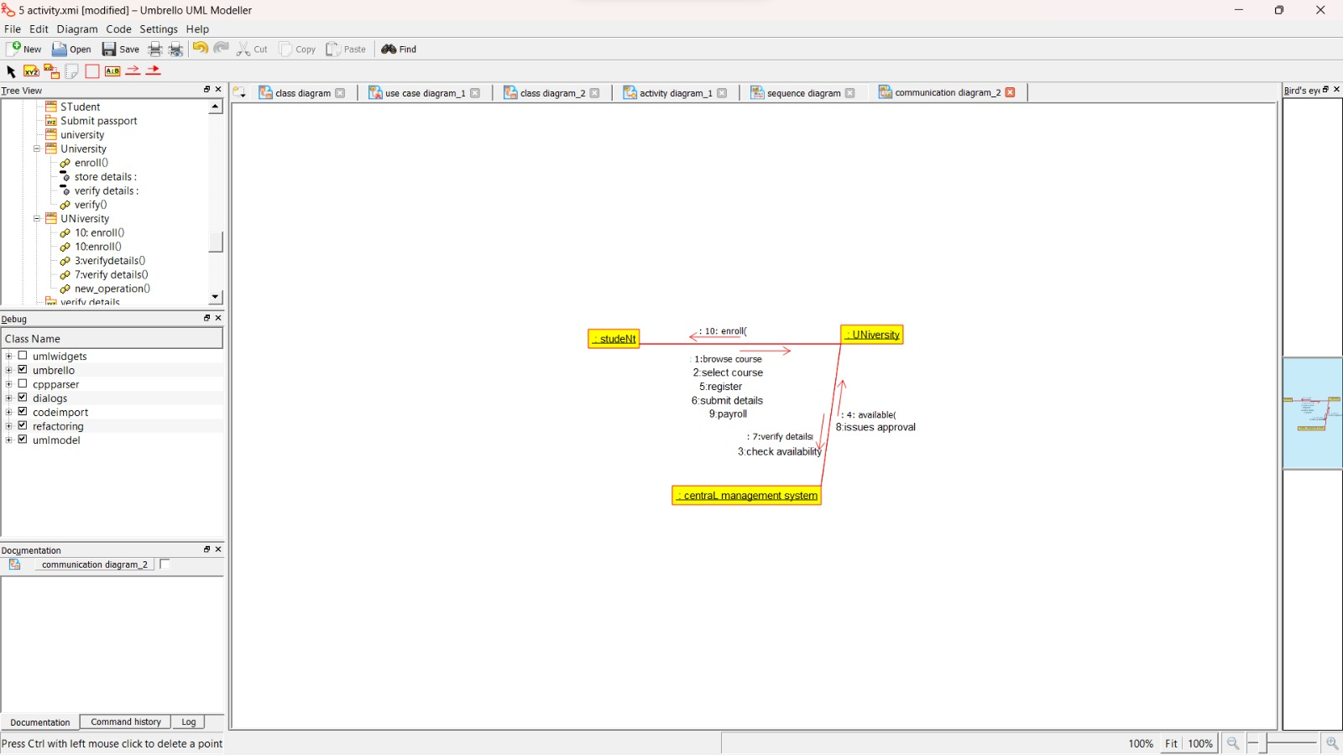

**State chart diagram:**

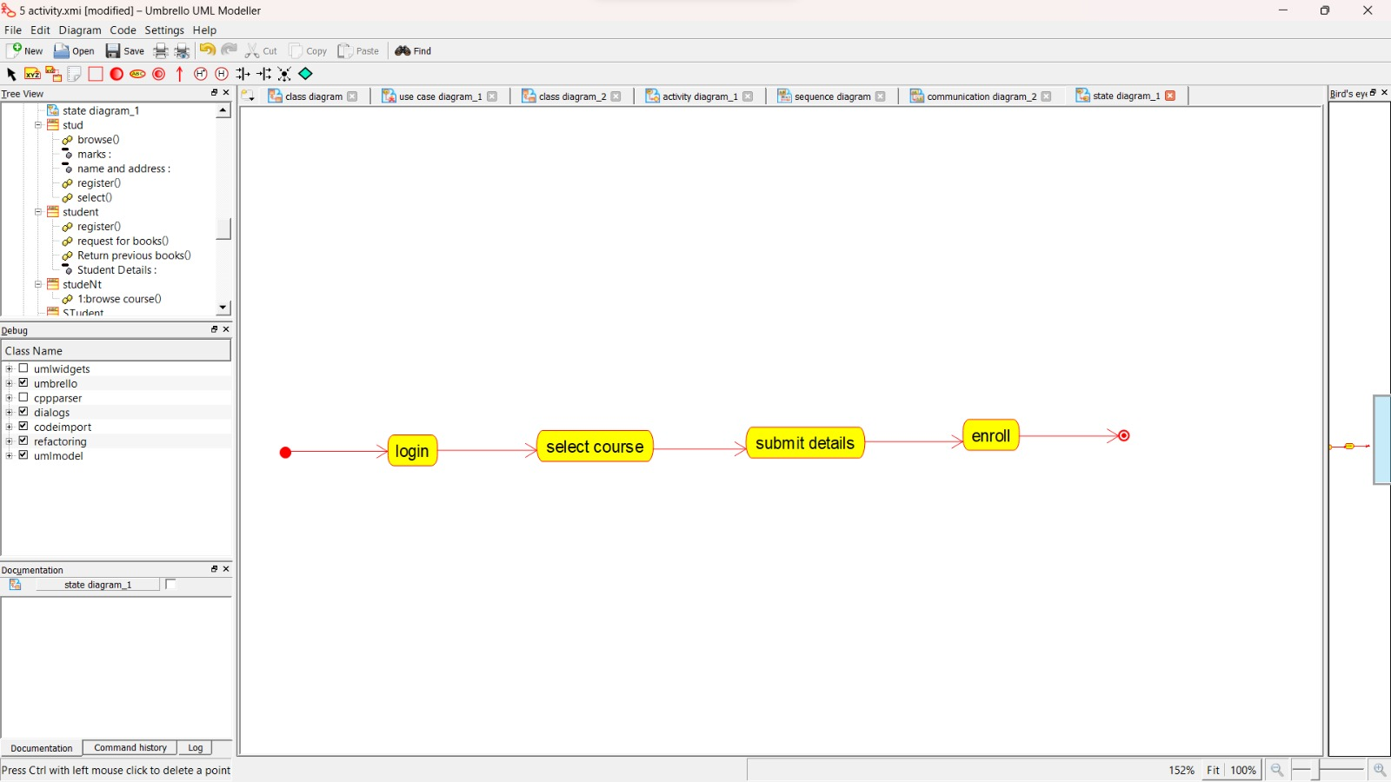

**Component diagram:**

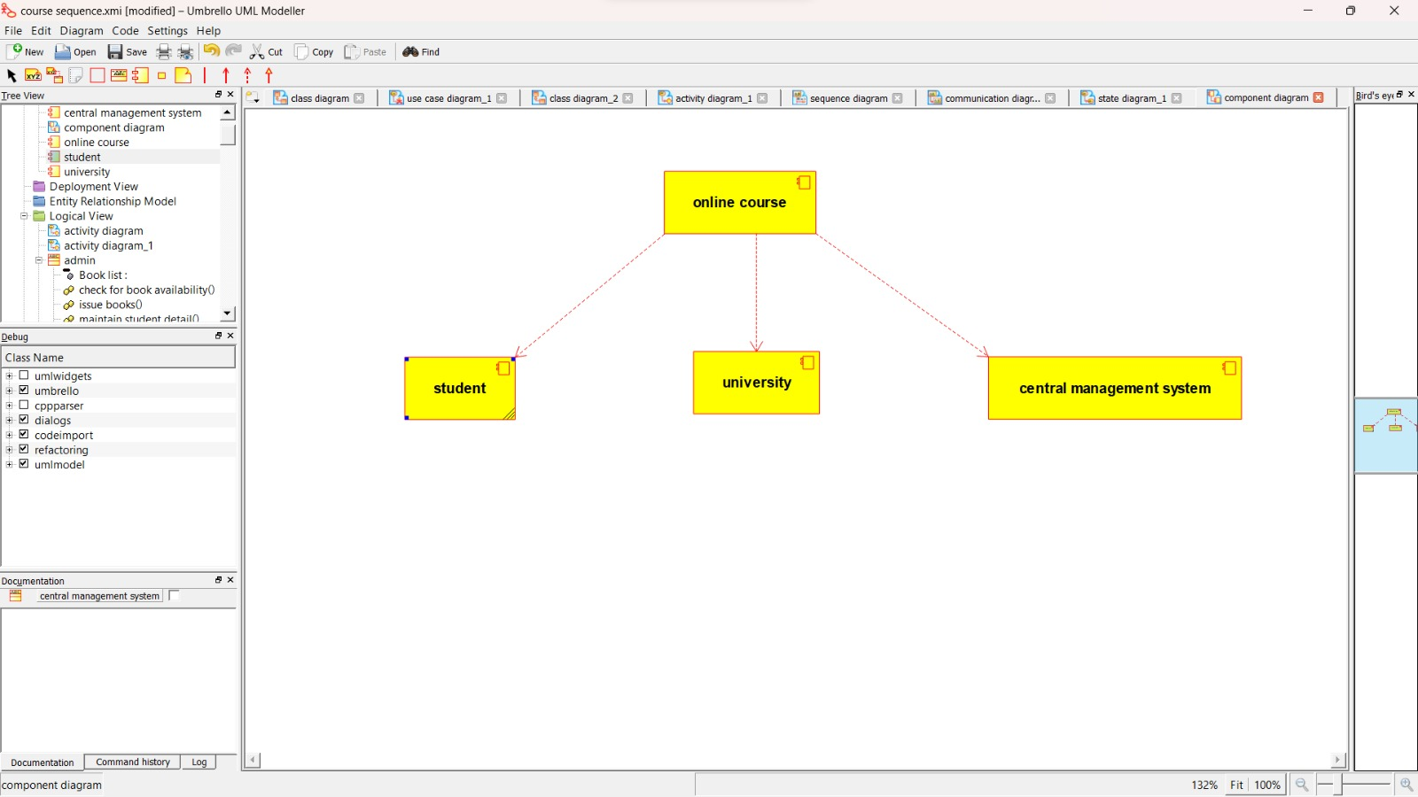

**Deployment diagram:**

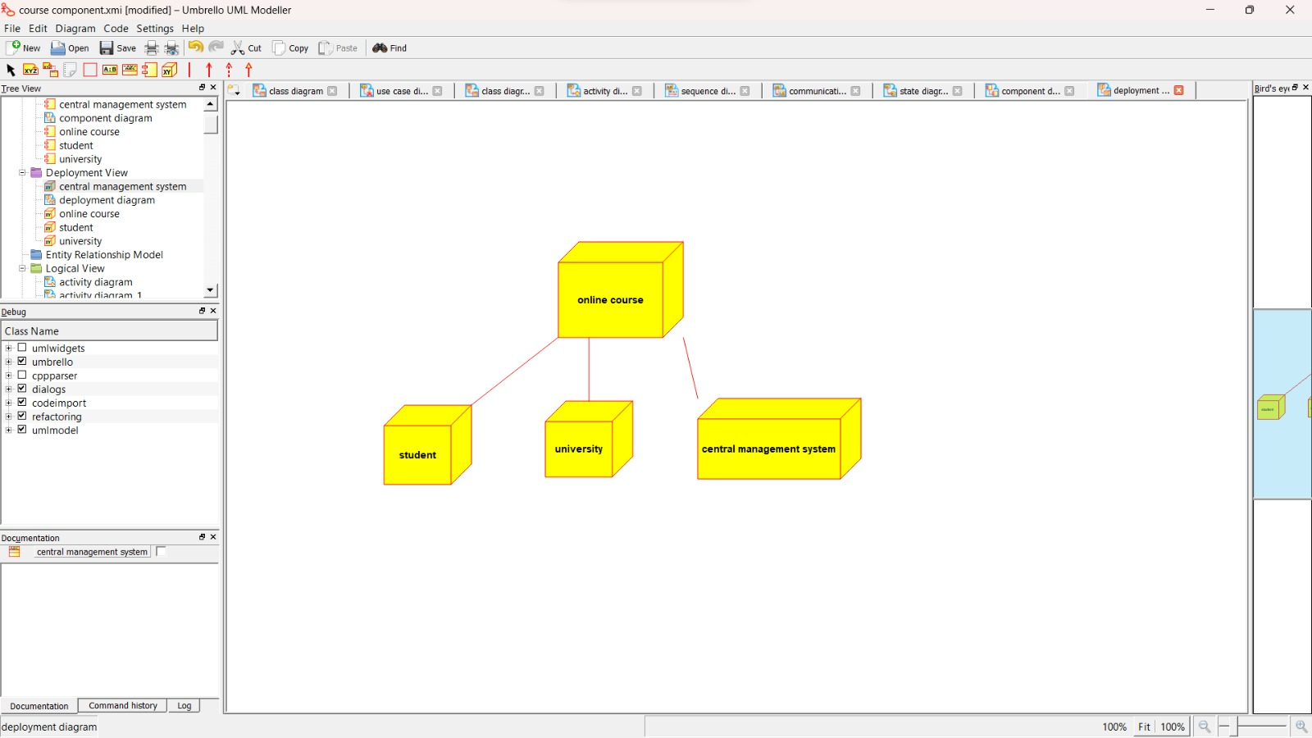

**Package diagram:**

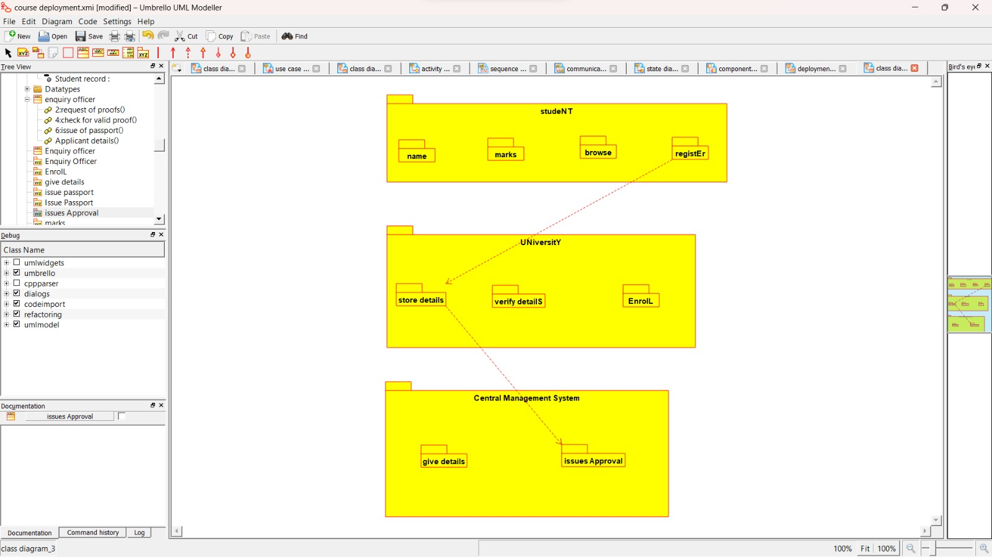

**Program:**

**CENTRAL MANAGEMENT SYSTEM**

Public class central management system

{

Public integer details;

Public integer verify details;

Public void verify()

{

}

Public void enroll()

{

}

}

**STUDENT:**

Public class student

{

Public integer name;

Public integer address;

Public integer marks;

Public void browse()

{

}

Public void select()

{

}

Public void register()

{

}

}

**UNIVERSITY**:

Public class university

{

Public integer store details;

Public integer verify details;

Public voidverify()

{

}

Public void enroll()

{

}

}

4:E-TICKETING

Use case diagram:

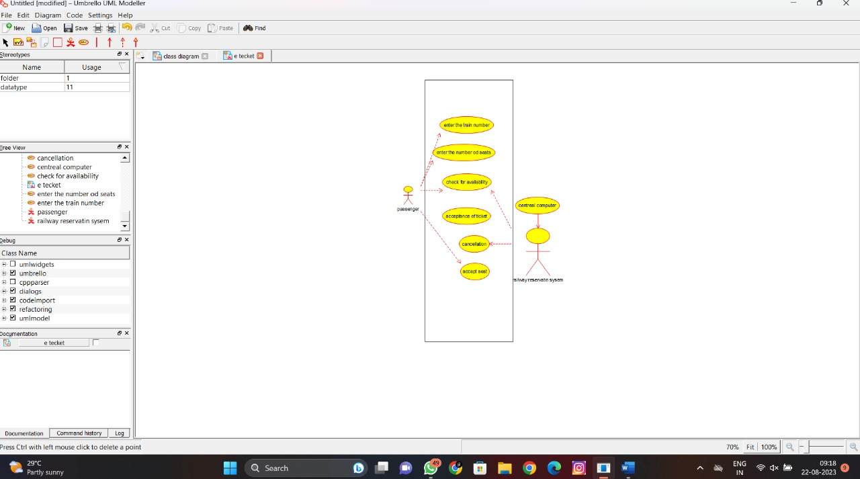

Class diagram:

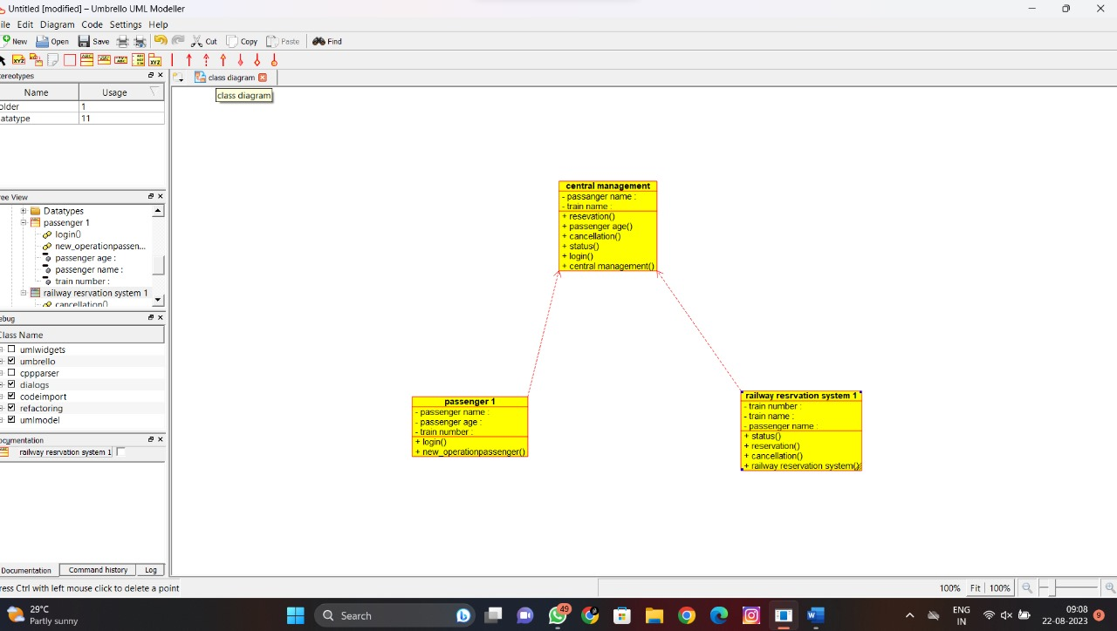

Activity diagram:

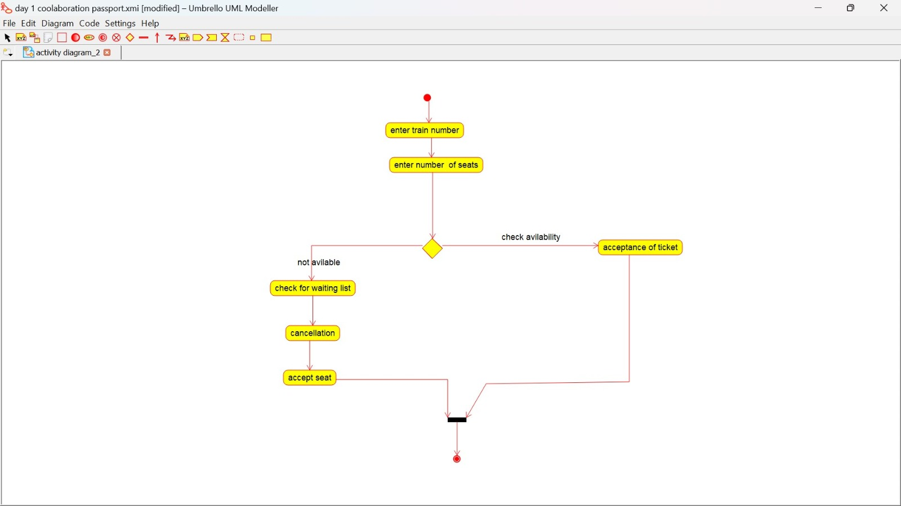

Sequence diagram:

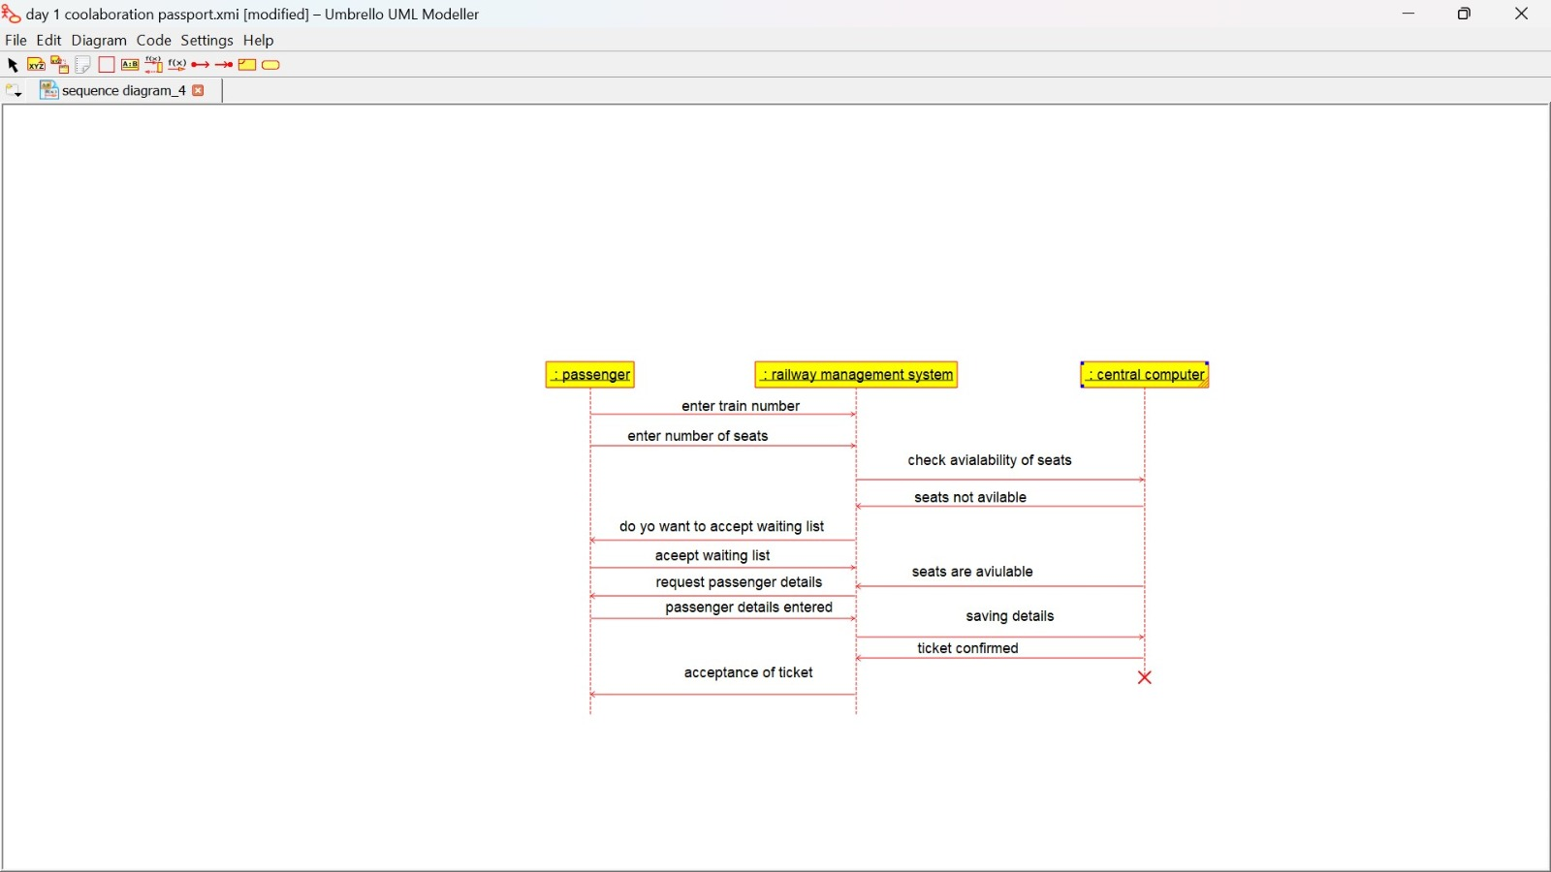

Collaboration diagram:

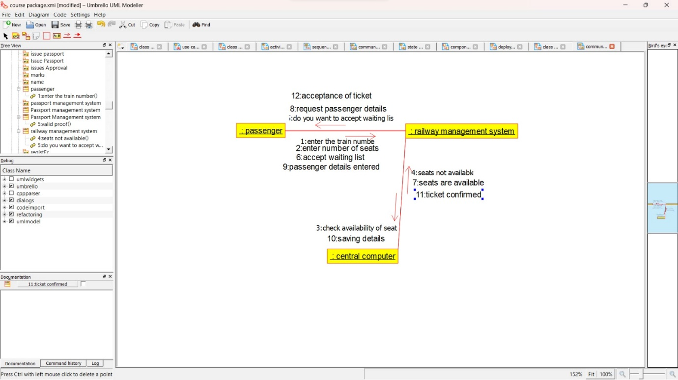

State chart diagram:

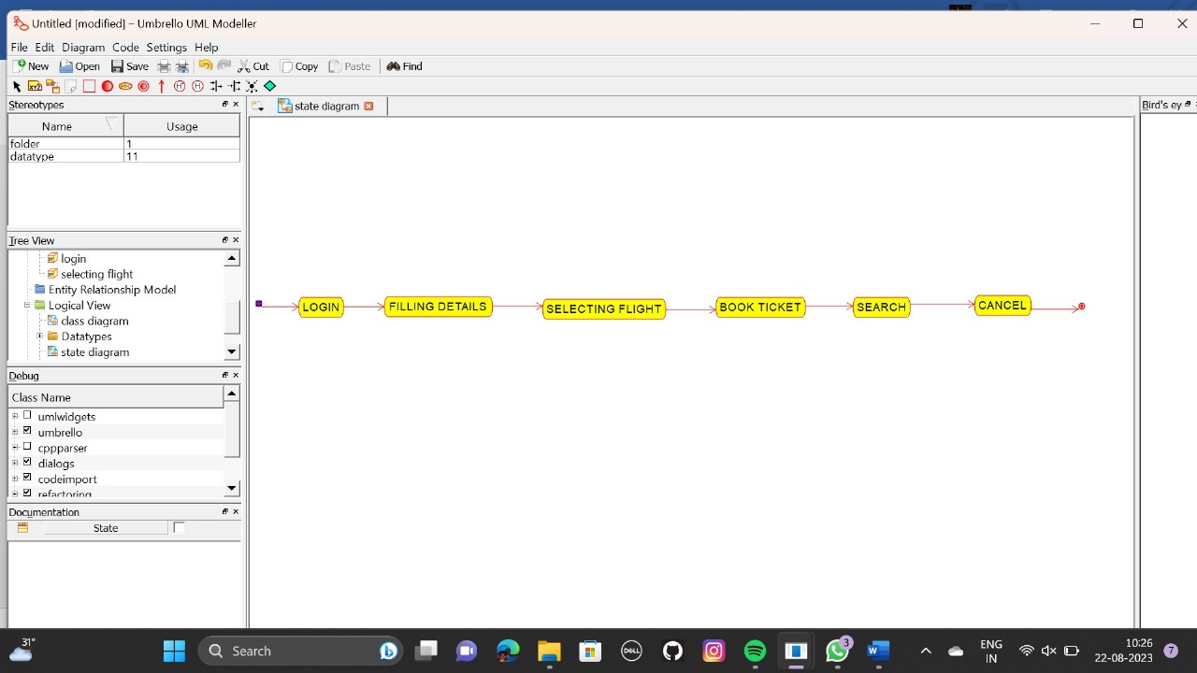

Component diagram:

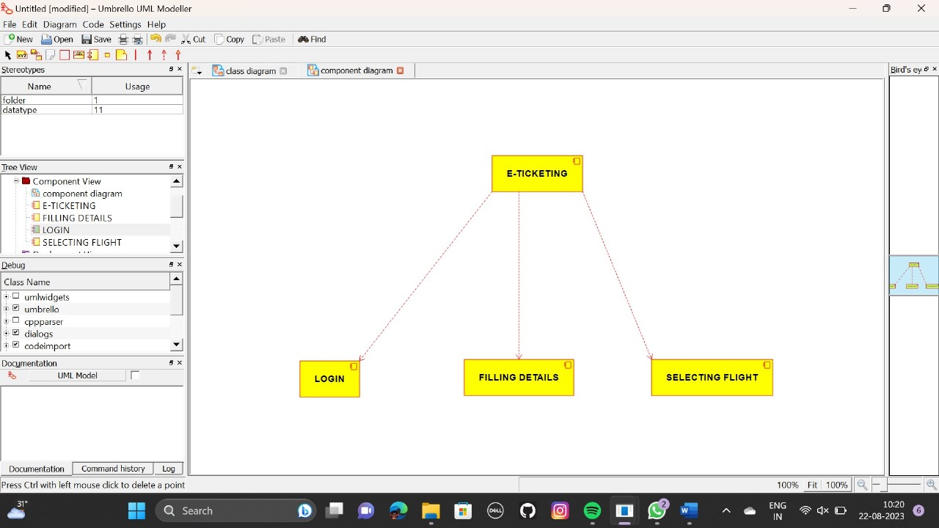

Deployment diagram:

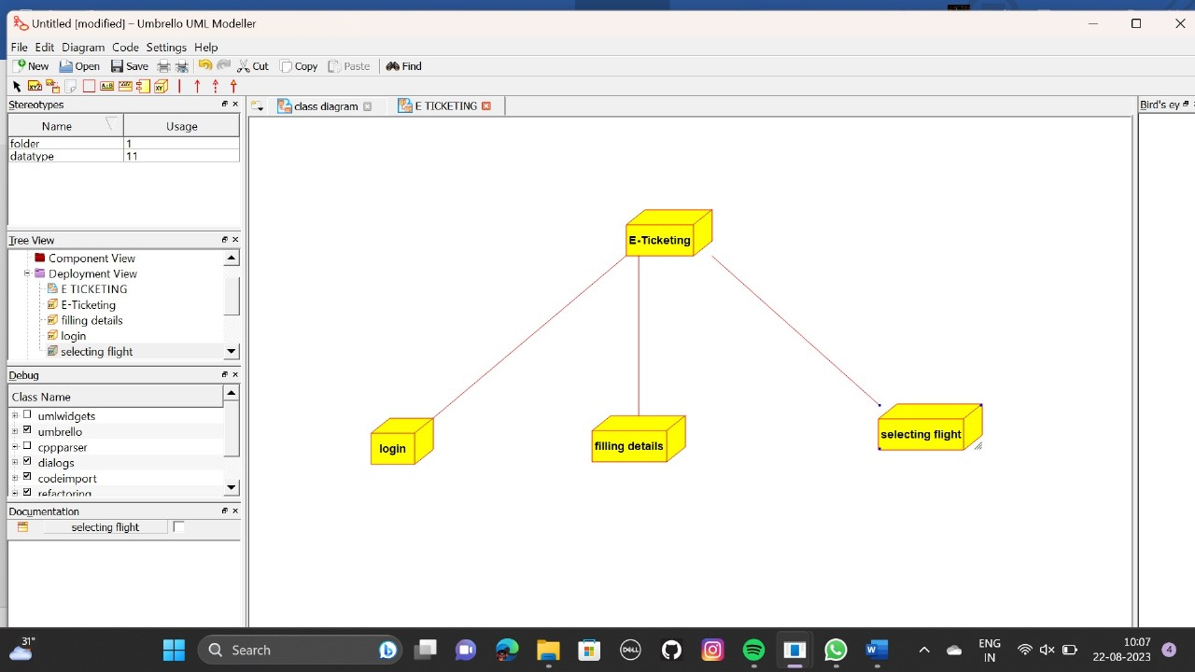

Package diagram:

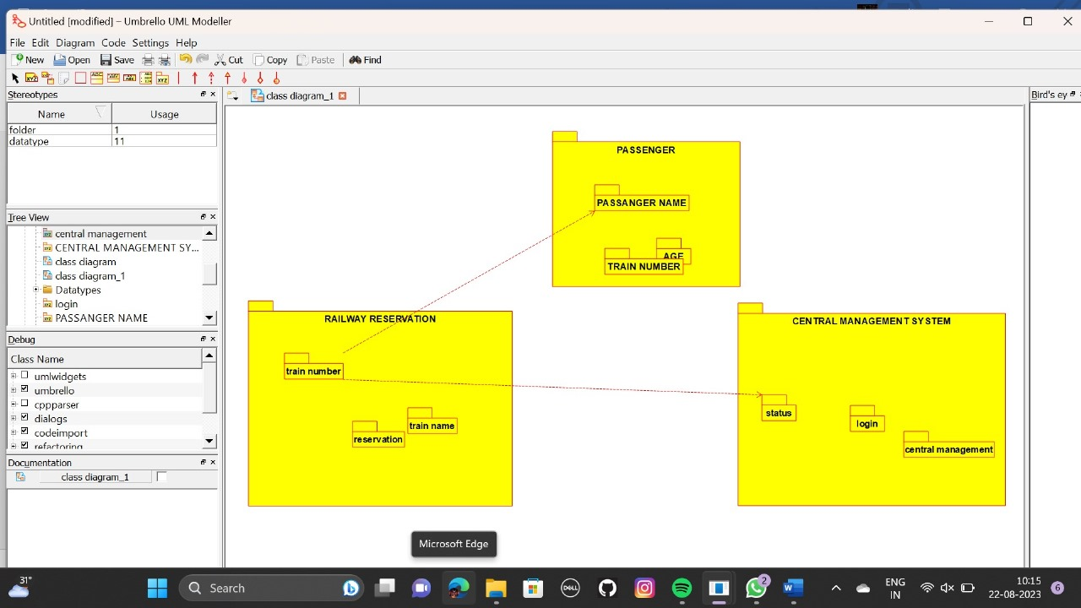

Program:

**PASSENGER:**

Public class passenger

{

Public integer passenger passenger name;

Public integer passenger passenger age;

Public integer train no;

Public void passenger()

{

}

Public void new operation()

{

}

}

**CENTRAL MANAGEMENT SYSTEM:**

Public class central management

{

Public integer train name;

Public integer passenger name;

Public void reservation()

{

}

Public void cancellation()

{

}

Public void status()

{

}

Public void login()

{

}

Private void management()

{

}

}

**RAILWAY RESERVATION SYSTEM:**

Public class railway reservation system

{

Public integer trainno;

Public integer train name;

Public integer passenger name;

Public void status()

{

}

Public void reservation()

{

}

Public void cancellation()

{

}

Public void railway reservation system()

{

}

}